**Korean Melon Disease Detection**

Korean melon disease diagnosis using CycleGAN, Comparison between CNN and SVM



Yunji Noh (21102357), Yerang Lee (21102377)

May, 2022

Department of Applied AI

Seoul National Univ. of Science and Technology

**Abstract**

It aims to minimize the damage to the reduction in Korean melon harvest due to plant disease by creating a plant disease diagnosis model with melons enjoyed by Koreans. The data were augmented through CycleGAN to obtain additional data due to the lack of data numbers of health images and disease images, and we tried to compare the accuracy of SVM and CNN models and improve the model performance using resource data and augmented data from AI Hub. CNN model showed higher accuracy than SVM overall, and training with augmented data helps to improve model performance.

1. **Introduction**

As the population of the world increase, demands of crops also is increasing. However, plant diseases are reducing crops yields. Plant disease are occurred because of plant fungus, and it calls “Biotrophs” because plant fungus is parasitic in living organisms. It typically becomes the cause of downy mildew, powdery mildew and phytoplasma. Downy mildew and powdery mildew that causes these diseases also occur in Korean melon, which is the subject of this study. Both diseases are fatal to crop yields. Especially, downy mildew of Korean melon occurs in March to May, which overlaps with the initial harvest season, and during this period, the price of Korean melons is high, causing greater economic losses than the loss caused by the powdery disease. Thus, plant disease diagnosis systems can be used to minimize such crop damage. Actually, in Korea, LAON PEOPLE Inc. is trying to prevent the damage of crops by plant diseases through AI deep learning model that is called “AI smart-farm solution”. Likewise, we proceeded our research to prevent the damage to crops caused by plant disease.

The subject of our study is to diagnose Korean melon disease to see if they are healthy or have a disease (Fig.1) by using three of machine learning models such as CycleGAN, CNN (Convolution Neural Network) and SVM (Support Vector Machine). To add more, we chose Korean melons as the theme since we recognized the lack of research on diagnosing plant disease on Korean melons, which are enjoyed to eat mainly in Korea.

The objective of our study is to find the effective model in performance and to improve the accuracy of plant disease diagnosis, so we are going to propose a data augmentation method that generates fake Korean melon disease images through CycleGAN to see if the data shortage problem can be solved. In addition, we are going to compare between CNN and SVM to find a high-accuracy model.

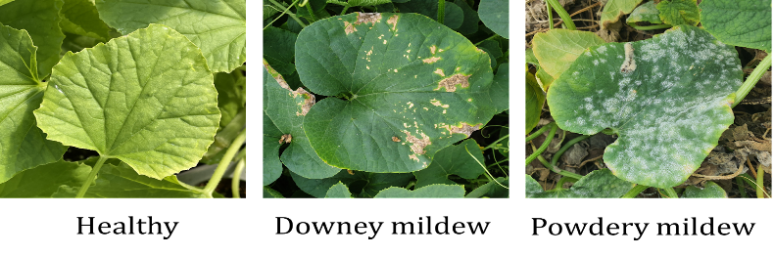

**Fig. 1.** Images of Healthy or Non-Healthy

1. **Related Work**

There are many overseas cases of plant disease detection studies using CNN. Sharma [2] showed that 10 classes of tomato leaves can be designed with high accuracy classification models through CNN models and image segmentation.

Since dataset like plant-village-image has the similar background and illumination in Sharma, research shows that it decreases less than 40% about the online resource even though it has high-accuracy more than 97%. Therefore, we are going to create a specialized classification model for Korean crops using Korean crops image that are afforded from AI hub that we trust. Because of the small number of data provided to create the robust model, we considered how to augment the data.

1. **Dataset and Features**

In our research, we use a dataset of Korean melon leaves images that contain healthy leaves and non-healthy leaves that have two types of disease such as downy mildew, powdery mildew. The data for training and testing were obtained from the facility crop diagnostic image folder of the AI Hub. Health images afford more than 19000 images, including fruits, flowers, stems, leaves. However, only 851 disease images were provided by combining two classes.

Therefore, in order to prevent imbalance of data, we only used 450 images of two types of disease each. Since symptoms of Korean melon diseases appear in the leaves, only the leaf part was included as a healthy image. Among of them, 80% of images were used in training, each 10% of images were used in validation and testing. When SVM was tested, we used validation data to test the SVM model instead of using test data that are used when we test the model, so the total of the data used is 90 when we tested SVM model.

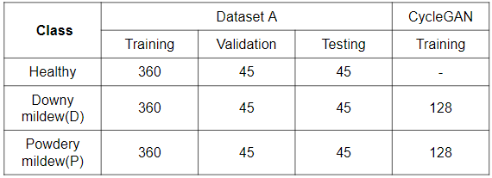Labeled json files including coordinates of the bounding box of the main part of the object were provided with images, so training data and validation data were used by cutting only the main object parts. After then, it reduced its 3000*4000 high-resolution image to 700*700 (Table.1).

**Table 1.** Used dataset in our study

1. **Methods**

In our study, there are the performance comparison between CNN and SVM, and it is to augment the data using CycleGAN.

* 1. Data Augmentation using CycleGAN

CycleGAN is a model that aims to solve the image-to-image translation problem. For instance, it changes the horse image to zebra image or change the photograph to the picture of Van Gogh’s style.

In other words, it is an image-to-image translation that changes style while maintaining the framework of the existing picture. If characteristics of disease are added in shapes of healthy leaves using this method, it can generate new fake disease images. If the performance improvement is confirmed by applying the generated dataset to actual learning, it can be seen that the limit of the small number of source data can be overcome.

We compared the test-accuracy of models between model that is trained by using source dataset only and model that is added augmented dataset through CycleGAN in order to validate the data generated by the style transition. CycleGAN referred to the code of selfie2anime-CycleGAN-PyTorch [1] in Kaggle, and designated the image size as 128 and the batch size as 16. 128 disease images were generated from the model learned with 100 epochs and used as augmented data.

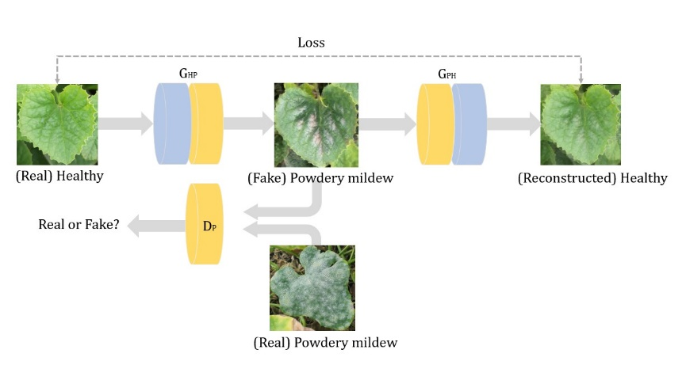

**Fig. 2.** The structure of CycleGAN

* 1. Classifier
     1. CNN

Since CNN learns characteristics of data on their own, it is useful to find the disease pattern. If it reads the images, the images are extracted 120*120 pixel and a little zoom is applied. After then, each value was made to have a value between 0 and 1 through rescaling. The model added a residual block to prevent vanishing gradient problem. From three RGB channels, which is an input value, it increases the number of channels from 32 to 64. In the process of extending channels to 128, 256, 512 and 728, a total of four skip connections were created by adding a residual block. After increasing to 1024 channels, the feature was made one-dimensional vector using global average pooling with a fluid input image size instead of a fully connected layer. It applied multi-convolution as CNN model controls the stride length, and then batch normalization, ReLU, and pooling are repeated.

Pooling simplifies the output by applying a mask to each pixel and then selecting a maximum value. Because of shortage of dataset, we used the Drop-out method, considering the possibility of overfitting to occur is very high. Final output was applied to the SoftMax function and trained the weight of model. As it implements through the network, the size of output of image data will be reduced, which makes it possible to detect important feature.

* + 1. SVM

SVM is useful to predict problem or category, and there is no effect on the error data, so we conducted the image classification using SVM that can be use easily because it is less overfitting. To be specific, research on image classification with SVM from existing plant disease diagnosis models was insufficient, and since CNN is mainly used as a classification model, we tried to find out why the SVM model is not used well. The process of Korean melon disease diagnosis model with SVM of our study is as follows. If user puts Korean melon image’s link as input value, the results of each class are divided into three classes, such as healthy, downy mildew, powdery mildew, and are stochastically represented. model shows probability values. Used hyperparameters are C = 1, gamma = 0.001, and kernel = poly. In addition, the size of image of training data is 150*150 pixel.

1. **Results**

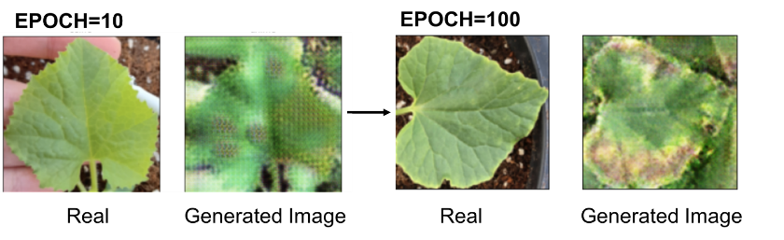Fig.3 shows healthy leaf and downy mildew leaf that was generated through CycleGAN. The higher the number of EPOCH, it indicates the disease characteristics well.

**Fig. 3. Images made by CycleGAN**

Table 2 indicates test accuracy of each model. A test accuracy of CNN model was 18.52% higher when we compare CNN model and SVM model

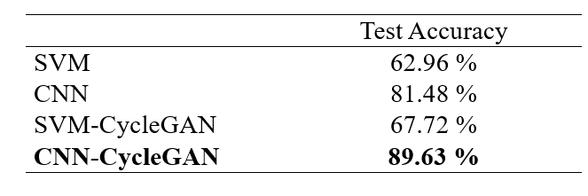

**Table 2.** Test accuracy of each model

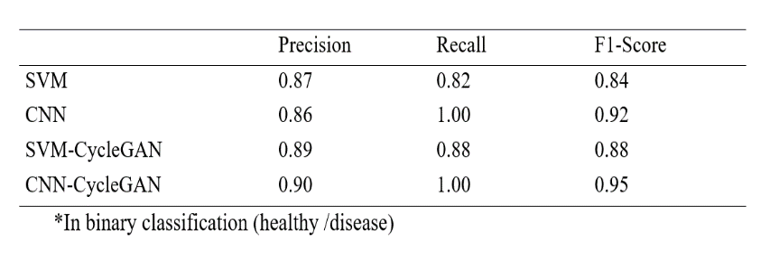

**Table 3.** Precision, Recall, F1-Socre of each model

Fig.4 (a), (b) are confusion matrices of SVM. Confusion matrix shows the corresponding case of detected class for each true class. The diagonal line represents a self-classification case and each diagonal element is 90. Fig.4 (c), (d) are confusion matrices of CNN. The probability of corrected answer about case that we predicted that it is healthy image is 100%. In the case of adding augmented data (b), (d), the case of misdiagnosing powdery mildew as a downy mildew in both SVM and CNN models decreased. A problem of confusing the types of disease symptoms can be solved by using data that was generated by CycleGAN.

The sensitivity of the CNN model can be seen as very high when considering only the presence or absence of a disease using the confusion matrix [Table 2], [Table 3]. In the problem of detecting diseases, sensitivity is more important, so it can be seen that it shows good results. In addition, when CycleGAN data was added, precision and F1 score were increased in the two models.

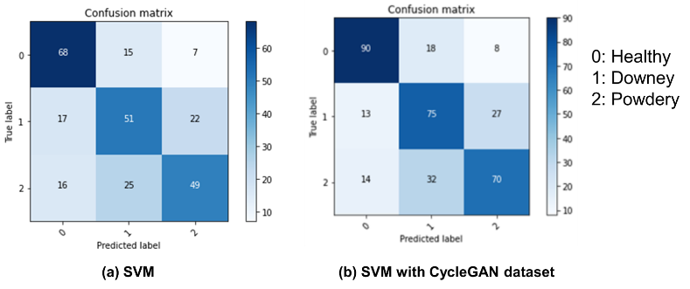

**Fig. 4.** Confusion matrix with SVM (a, b)

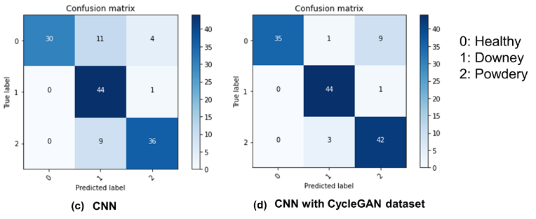

**Fig. 4.** Confusion matrix with CNN (c, d)

1. **Conclusion**

In our study, it shows the possibility of successful disease detection system using data augmentation through CycleGAN and classification model with CNN. When model was trained by using source data, CNN model showed high accuracy of 18% than SVM. On the other hand, when the model was trained using augmented data, the accuracy of detecting types of diseases was improved. Data augmentation through fake image generation can prove valuable things to achieve high performance of the Korean melon disease classification model.

The primary limitations that our study faced was the lack of disease dataset. Although the model is very sensitive because of lack of data, it will be able to ensure a robust result more than before if dataset is sufficiently replenished in the future studies.

The future work could include making the model that detects only the lesion site by drawing a bounding box that displays only ROI (Region of interest). In addition, utilizing controllable image generation models such as GIRAFFE and MVCGAN could be worth consideration. These models create images, considering three-dimension, so we will investigate how this approach affects real-world.

1. **Reference**

[1] Boulent, J., Foucher, S., Théau, J., & St-Charles, P. L. (2019). Convolutional neural networks for the automatic identification of plant diseases. *Frontiers in plant science*, *10*, 941.

[2] Sharma, P., Berwal, Y. P. S., & Ghai, W. (2020). Performance analysis of deep learning CNN models for disease detection in plants using image segmentation. *Information Processing in Agriculture*, *7*(4), 566-574.

[3] Sandfort, V., Yan, K., Pickhardt, P. J., & Summers, R. M. (2019). Data augmentation using generative adversarial networks (CycleGAN) to improve generalizability in CT segmentation tasks. *Scientific reports*, *9*(1), 1-9.

[4] https://www.kaggle.com/code/ninamaamary/ selfie2anime-cyclegan-pytorch/notebook

[5] https://github.com/ShanmukhVegi/Image-Classification/blob/main/Shanmukh_Classification.ipynb